**Method 1# 2#**

CREATE OR REPLACE TYPE employee AS OBJECT (

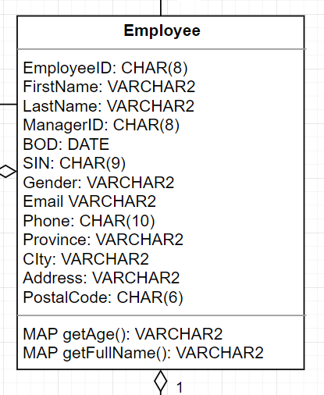 firstname VARCHAR2,

lastname VARCHAR2,

bod DATE,

MAP MEMBER FUNCTION getage RETURN VARCHAR2

MEMBER FUNCTION getfullname RETURN VARCHAR2);

/

CREATE OR REPLACE TYPE BODY employee AS

MAP MEMBER FUNCTION getage RETURN VARCHAR2 IS

BEGIN

RETURN TRUNC((SYSDATE-bod)/365);  
END;

MEMBER FUNCTION getfullname RETURN VARCHAR2 IS

BEGIN

RETURN CONCAT(firstname, ‘ ’, lastname);

END;

END;

/

**Method 3#**

CREATE OR REPLACE TYPE jobhistory AS OBJECT (

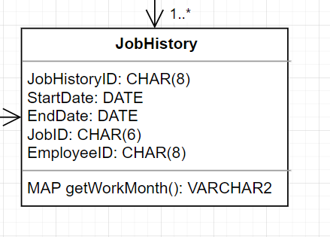 startdate DATE,

enddate DATE,

MAP MEMBER FUNCTION getworkmonth RETURN VARCHAR2);

/

CREATE OR REPLACE TYPE BODY jobhistory AS

MAP MEMBER FUNCTION getworkmonth RETURN VARCHAR2 IS

BEGIN

RETURN TRUNC((enddate - startdate)/30);  
END;

END;

/

**Method 4# 5#**

CREATE OR REPLACE TYPE job AS OBJECT (

rank NUMBER,

ORDER MEMBER FUNCTION comparerank (j job) RETURN NUMBER

NOT INSTANTIABLE MEMBER FUNCTION calculateSalary RETURN NUMBER)

NOT FINAL;

/

CREATE OR REPLACE TYPE BODY job AS

ORDER MEMBER FUNCTION comparerank (j job) RETURN NUMBER IS

BEGIN

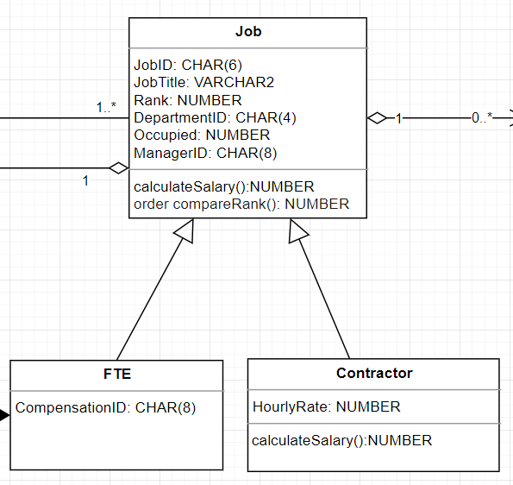IF rank < j.rank THEN

RETURN -1;

ELSIF rank > j.rank THEN

RETURN 1;

ELSE

RETURN 0;

END IF;

END;

END;

/

CREATE TYPE contractor UNDER job(

hourlyrate NUMBER;

MEMBER FUNCTION calculateSalary RETURN NUMBER);

/

CREATE OR REPLACE TYPE BODY contractor AS

OVERRIDING MEMBER FUNCTION calculateSalary (workhours NUMBER) RETURN NUMBER IS

BEGIN

RETURN (hourlyrate * workhours));  
END;

END;

**Method 6# ~ 10#**

